|  |
| --- |
| PROJECT AND TERM PAPER |
| Fuzzy logic : And its usage in automatic braking system |
| **EXPERIMENTAL INVESTIGATION INTO THE FUZZY METHODS OF DECISION MAKING** |
|  |
| **By Reetam Das B.E Production engineering 3rd year 1st Semester Roll - 00211171101** |
| **GUIDED BY DR. BIPLAB RANJAN SARKAR** |

**ABSTRACT**

Fuzzy Logic is a branch of mathematics that deals with reasoning and decision making with incomplete or uncertain information. It was developed in the 1960s by Lotfi Zadeh, a professor at the University of California, Berkeley. Fuzzy Logic has been applied to a variety of fields, including control systems, artificial intelligence, decision support systems, image processing, and data mining. In this report, we will explore the evolution of fuzzy logic and explain the top fuzzification and defuzzification techniques. Here then we describe an automatic AC with the fuzzy set of distance data and calculated it’s different speeds accordingly. Car prototype is designed by using Fuzzy Logic Control. Fuzzy logic is as main component of artificial intelligence has significantly influence the design controlled system. Fuzzy logic system is integrated with the arduino Mega 2560 microcontroller as the central control car prototype. In this paper, the Fuzzy logic used Mamdani method and 28 rule base. The fuzzy system was made based on fuzzy mechanism which are fuzzification, inference and defuzzification. Fuzzy logic has a variable input and output variables. Input variables used in this research is the distance between car and obstacle; the speed of car prototype and the output variable is the brake angle. The test is done with 5 variations of distance that is 100 cm, 125 cm, 150 cm, 175 cm, and 200 cm and two variations of speed that are 54 cm/s, and 63 cm/s. The test results showed that the prototype of the car was able to stop with a range of 22 cm - 35 cm from obstacle. The highest deceleration value at the speed of 63 cm/s is - 49.22 cm/s2 and the accuracy of braking on a system that has been designed is between 99.91% -100%.

1. **Introduction:**

Fuzzy logic is a mathematical framework that deals with imprecise and uncertain information. Unlike classical logic, which operates with crisp binary values, fuzzy logic introduces the concept of partial truth and degrees of membership, allowing for a more flexible and realistic approach to decision-making and control systems.

At its core, fuzzy logic utilizes fuzzy sets to represent and quantify linguistic variables. Fuzzy sets employ membership functions to assign degrees of membership to elements based on their similarity to predefined categories or fuzzy sets.

One of the main advantages of fuzzy logic is its ability to handle ambiguity and uncertainty in a systematic manner. By using fuzzy rules, which consist of if-then statements encoding expert knowledge, fuzzy logic enables approximate reasoning and inference, making it suitable for applications where precise mathematical models are unavailable or impractical.

Fuzzy logic finds wide-ranging applications in various fields, including control systems, pattern recognition, decision-making, and artificial intelligence. Its intuitive and interpretable nature, combined with the capacity to model and reason with imprecise information, makes fuzzy logic a valuable tool for solving real-world pro. Drivers are annoyed of the current automated braking systems. The failure of braking systems causes the majority of four-wheeled vehicle accidents. To reduce the number of accidents, it is vital to use electronic equipment to manage brakes automatically. The ability to recognize a driver's intent offers a huge potential for automated driving. In the event of a frontal accident, current automated emergency braking (AEB) systems notify the driver and assume control of the vehicle. To avoid annoyance, it is critical to determine the driver's intent before beginning such transitions to automated driving. A novel reference-free shared control system for obstacle avoidance for driverless vehicles is proposed in this research. The suggested framework imposes restrictions on the vehicle's state in order to ensure safety while preserving the driver's autonomy.

**LITERATURE REVIEW:**

**F. Diederichs, T. Schuttke, and D. Spath [1]** analysed In the event of a frontal accident, current automated emergency braking systems notify the driver and assume control of the vehicle. To avoid annoyance, it is critical to determine the driver's intent before beginning such transitions to automated driving. The creation of a driver intention detection algorithm or automated emergency braking systems is described in this work. In the event that the driver already has a braking intention, this could be modified or aborted.

**A. Schneider, M. Lienkamp, R. Markus, and L. T. Munich Germany Franz [2]** analysed In the event that the driver already has a braking intention, this could be modified or aborted. When driver intention recognition suggests safe behaviour planning, the number of warnings can be decreased. Pedestrian protection systems, in particular, will be beneficial in metropolitan areas where pedestrians may frequently enter the vehicle's path.

**F. Kobiela and A. Engeln [3]** analysed in metropolitan areas where pedestrians may frequently enter the vehicle's path. Drivers' intention is measured using a standard procedure. Indicators such as an algorithm, for determining whether or not a driver intends to brake. Pedestrian protection with Active Safety Systems.

**M. A. Abu, Z. Kornain, I. M. Iqbal, and M. H. Rosli [4]** analysed Path-based techniques and reference-free approaches, both centered on the driving task and sharing a common reference trajectory, are two types of shared control systems.

**V. Handi, S. Jeyanthi and A. Giridharan [5]** analysed Model predictive control, rapidly exploring random trees and the geometric technique are all path-based planning methods.

**K. v Gawande, M. A. Shende, V. B. Meshram, and A. Professor [6]** analysed When the automobile is in reverse, an ultrasonic sensor on the back bumper is engaged. It detects an obstruction (vehicle) behind it and applies changing pressure to the automobile brakes until it comes to a complete stop. So a Network architecture (based on learning algorithm) and Sigmoid Activation Function Generator can be used in this case.

**C. Huang, P. Hang, J. Wu, A. T. Nguyen, and C. Lv [7]** analysed The findings highlight the issues at hand as well as the possibilities for implementing a "intelligent" control technique. The design of current automobiles has been profoundly influenced by the new generation of sensor-rich, distributed autonomous control technology.

**Michael Negnevitsky [8]** analysed Control systems that considerably improve vehicle performance have been developed using the intelligence provided by resilient embedded microelectronics throughout the vehicle, as well as communications network topologies.

1. **Kalhari, N. Wickramarathna, L. Yapa, D. Nandasena and L. Kalansooriya [9]** analysed he development of software simulation approaches that leverage a variety of system dynamic models with the goal of generating superior vehicle control strategies can lead to a better knowledge of vehicle performance.

**U.S. Department of Transportation [10]** analysed The current Bang-Bang Control implementation is extremely harsh in terms of the physical shock the driver feels when the system is engaged by brake pedal pulsations. The sections that follow assess various options and give an estimate of the level of system performance that can be attained.

**I. Fletcher, B. J. B. Arden, and C. S. Cox [11]** analysed The benefits of such intelligent control include the ability to take full advantage of advancements in Smart Tyre technology as well as the increasing integrity of microtechnology.

**T. Toroyan [12]** analysed Pneumatic technology is crucial in the fields of automation, modern machine shops, and space robots. Because of its simplicity and ease of operation, pneumatic systems can be effective in automation. The project's goal is to design and build a control system dubbed "automatic pneumatic braking system" that is based on an intelligent electronically controlled vehicle bumper activation system.

**OBJECTIVE**

The major goal of this paper is to review a vehicle speed control and automatic braking system. The system will be built to keep the driver and passengers safe inside the car. This research paper is to create a device that can successfully scan the surroundings while driving and apply brakes to avoid a vehicle front end collision, as well as bumper extension. This research paper also describes the creation of an artificial neural network-based car braking system for use during parking. The research might aim to design and implement a fuzzy logic controller specifically tailored for an ABS. This involves developing a control algorithm that considers various input parameters, such as vehicle speed, wheel speed, and road conditions, to optimize the braking system's response. The overarching objective may be to contribute to advancements in automotive safety by introducing a more effective and adaptive braking system. This could lead to safer driving experiences and a reduction in the number and severity of accidents related to braking.

1. **CHARECTERISTICS FEATURES AND DESIGN**

**Architecture of Fuzzy Logic:**

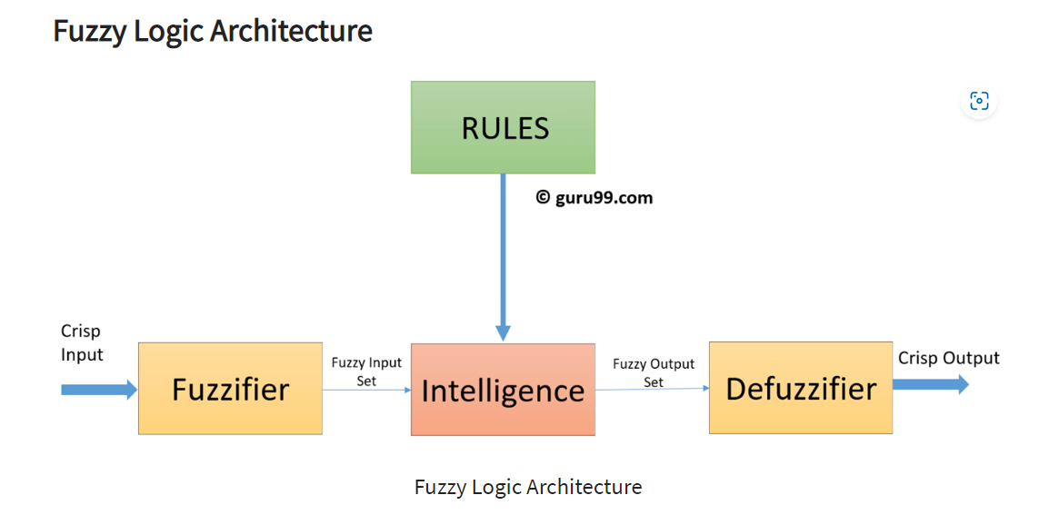

The architecture of fuzzy sets is based on the following components:

**Membership functions**: Membership functions define the degree to which a value belongs to a fuzzy set. There are many different types of membership functions, but the most common are triangular and Gaussian membership functions.

* + - 1. **Triangular membership functions**: Triangular membership functions are the simplest type of membership function. They are defined by three points: the minimum, the maximum, and the mean. The minimum and maximum points define the range of values that can belong to the fuzzy set, and the mean point defines the degree to which a value at the mean point belongs to the fuzzy set.

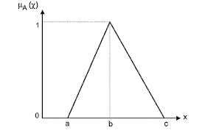

* + - 1. **Gaussian membership functions**: Gaussian membership functions are more complex than triangular membership functions. They are defined by two parameters: the mean and the standard deviation. The mean point defines the center of the fuzzy set, and the standard deviation defines the width of the fuzzy set.
    1. 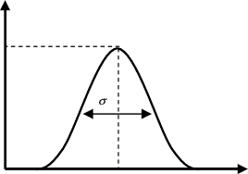

**Fuzzy rules**: Fuzzy rules, a fundamental component of fuzzy architecture, provide a mathematical representation of imprecise relationships between inputs and outputs. They play a pivotal role in capturing and modeling uncertainty in intelligent systems. Fuzzy rules are typically expressed in the form of "if-then" statements, where the "if" part contains antecedents and the "then" part consists of consequents.

Mathematically, fuzzy rules can be represented as follows: IF (Antecedent_1 is A_1) AND (Antecedent_2 is A_2) AND ... AND (Antecedent_n is A_n) THEN (Consequent is C)

Here, A_1, A_2, ..., A_n represent linguistic values associated with fuzzy sets, describing the degree of membership of the antecedents, while C represents the consequent linguistic value associated with a fuzzy set.

Fuzzy rules allow for the utilization of linguistic variables and fuzzy sets to model and reason with imprecise and uncertain data. The degrees of membership assigned to the antecedents and consequents enable gradual transitions between truth and falsity, providing a more nuanced representation of real-world phenomena. By employing fuzzy rules, intelligent systems can effectively handle imprecision and uncertainty, making them adaptable and robust in diverse problem domains.

**Inference engine(intelligence)**: The inference engine is responsible for applying fuzzy rules to the input data and generating an output. The inference engine can be implemented in a variety of ways, but the most common approach is to use a fuzzy logic controller.

A fuzzy logic controller is a type of controller that uses fuzzy logic to make decisions. A fuzzy logic controller typically consists of the following components:

* + 1. Fuzzy rule base: The fuzzy rule base contains the fuzzy rules that will be used to make decisions.
    2. Fuzzy inference engine: The fuzzy inference engine applies the fuzzy rules to the input data and generates an output.
    3. Defuzzifier: The defuzzifier converts the output of the fuzzy inference engine into a crisp value.

**Defuzzifier:** Defuzzification is the process of converting a fuzzy set to a crisp set. It is typically used in fuzzy logic control systems to convert the fuzzy output of the inference engine into a single value that can be used to control a system.

There are several different defuzzification methods, each with its own advantages and disadvantages. The most common defuzzification methods are:

Center of gravity (COG): The COG method calculates the center of gravity of the fuzzy set. This is done by taking the weighted average of all the values in the fuzzy set, where the weights are the membership degrees of the values.

Mean of maximum (MOM): The MOM method calculates the mean of the values in the fuzzy set that have the highest membership degrees.

Weighted average method: The weighted average method calculates the weighted average of all the values in the fuzzy set, where the weights are the membership degrees of the values.

The choice of defuzzification method depends on the specific application. In general, the COG method is the most common choice, as it is relatively simple to implement and it produces good results in most cases.

Example

Suppose we have a fuzzy set called "temperature" that has the following membership degrees:

0.2 for 0 degrees Celsius

0.5 for 20 degrees Celsius

0.8 for 40 degrees Celsius

The COG of this fuzzy set is calculated as follows:

Code snippet

COG = (0 * 0 + 20 * 0.5 + 40 * 0.8) / (0 + 0.5 + 0.8) = 28 degrees Celsius.

This means that the defuzzified value of the fuzzy set "temperature" is 28 degrees Celsius.

Applications

Defuzzification is used in a wide variety of applications, including:

* + 1. Fuzzy logic control systems
    2. Expert systems
    3. Data mining
    4. Image processing
    5. Natural language processing

**Evolution and usage of Fuzzy Logic:**

**Early Applications:** Fuzzy logic found its first practical application in the field of control systems, where it demonstrated remarkable capabilities in handling nonlinear and imprecise control problems. Fuzzy logic controllers offered an effective alternative to traditional control systems, especially in scenarios with limited or imprecise data.

**Fuzzy Logic in Pattern Recognition**: Fuzzy logic has been successfully applied to various pattern recognition tasks, including image processing, speech recognition, and natural language processing. By incorporating fuzzy sets and fuzzy inference systems, these applications can handle imprecise and ambiguous data, improving recognition accuracy and robustness.

**Fuzzy Logic in Decision-Making**: Fuzzy logic has proven valuable in decision-making processes, particularly in situations involving subjective and uncertain criteria. Fuzzy decision-making models enable the integration of multiple factors with imprecise information, allowing decision-makers to handle complex trade-offs and reach more informed decisions.

**Fuzzy Logic in Expert Systems**: Fuzzy logic has been widely employed in expert systems, which aim to emulate human expertise in specific domains. By capturing the linguistic knowledge of domain experts and incorporating fuzzy rules, expert systems can provide valuable insights and recommendations even when dealing with uncertain or incomplete information.

**Usage of Fuzzy Logical systems is Industrial Engineering:**

**Quality Control**: Fuzzy logic has been applied to quality control processes in manufacturing. By incorporating fuzzy rules and membership functions, fuzzy logic-based quality control systems can handle imprecise measurements and variations in production parameters. This allows for real-time monitoring and adjustment of manufacturing processes to maintain consistent product quality.

**Supply Chain Management:** Fuzzy logic has been utilized in supply chain management to optimize inventory control and demand forecasting. Fuzzy models can handle uncertainties and fluctuations in demand patterns, enabling better inventory management decisions. By considering multiple factors and linguistic variables, fuzzy logic can assist in determining optimal order quantities and reorder points to minimize stockouts and excess inventory.

**Process Optimization:** Fuzzy logic plays a crucial role in process optimization, particularly in complex industrial systems. By modeling the relationship between various process variables, fuzzy logic controllers can adjust parameters in real-time to optimize performance. This includes optimizing energy consumption, reducing waste, and improving efficiency in manufacturing processes.

**Fault Diagnosis**: Fuzzy logic-based fault diagnosis systems are used in industrial engineering to identify and diagnose equipment malfunctions and failures. By analysing sensor data and incorporating expert knowledge, fuzzy logic can accurately detect and classify faults, even in the presence of noisy or incomplete data. This allows for timely maintenance and repair, minimizing downtime and improving overall system reliability.

**Human-Machine Interface**: Fuzzy logic has been employed in human-machine interfaces (HMIs) to enhance user interaction and control in industrial settings. Fuzzy logic-based HMIs can interpret imprecise or linguistic inputs from operators and provide appropriate control signals to machines or systems. This enables more intuitive and natural communication between humans and machines, improving overall system performance and safety.

**Risk Assessment**: Fuzzy logic-based risk assessment models are utilized in industrial engineering to evaluate and mitigate risks associated with complex systems or processes. By considering multiple parameters and their degrees of membership, fuzzy logic can assess the likelihood and severity of risks, allowing for proactive measures to be taken. This aids in decision-making regarding safety protocols, maintenance schedules, and resource allocation.

**Design Automatic Braking System**

Automatic braking system design based on Arduino mega 2560 microcontroller by using fuzzy logic method devided into input, process and output. The workings of automated braking prototype of the car to be designed is when the input speed of the potentiometer is Pulse Width Modulation (PWM) and ultrasonic sensors detect the presence of obstacles with a certain distance, then automatically fuzzy logic integrated with arduino mega 2560 will process input from the sensor to determine the output of the braking angle on the prototype of the car. The design of an automatic braking system using the fuzzy logic method needs to determine the variables that can influence and become a reference for the final result. A variable is characteristics or values to determine the possibility of changing one thing to another. The variables divided into three, namely control variables, dependent variables and independent variables. The control variables are variables that are controlled or made constant so that the influence of the independent variable on the dependent variable is not influenced by external factors that are not examined.

The control variable is determined to make it easier to work on the braking system design automatic braking. The control variable that has been determined is the distance to the emergency stop, where the prototype car must stop ≥ 15 cm to the obstacle. The selection of the emergency distance as the control variable is to avoid a collision between the prototype car and the obstacle, so that the prototype car always stops at a safe distance. The independent variable is a variable that affects the dependent variable. Treatment can take the form of efforts made to be able to see the changes that occur in the dependent variable. The independent variable can also be said to be a variable that has an effect on the experiment. The independent variable in the design of an automatic braking system using the fuzzy logic method is the distance between the prototype car and the obstacle and the speed of the prototype car. The distance variation in the design of the automatic braking system is 100 cm, 125 cm, 150 cm, 175 cm, and 200 cm. The variations in the speed of the prototype cars are 100, 150, 200, and 255. The choice of distance and speed variations is adjusted to the predefined membership function range. The dependent variable is a variable whose value will change against certain factors. In general, experimental types of research seek only one type of independent variable that affects the dependent variable. The change in the value of the dependent variable will be proportional to the treatment given by the independent variable. The dependent variable in this study is the stopping distance, the deceleration value and the braking angle value of the prototype car

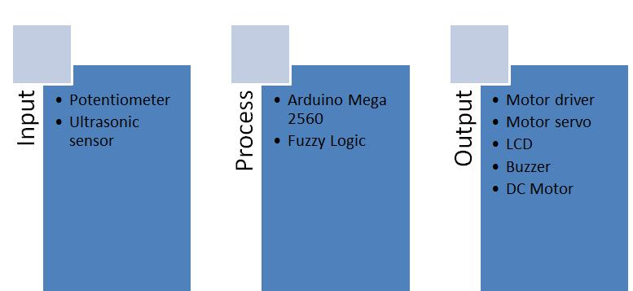

**Figure. 1** Block Diagram of Automatic Braking System

1. **PLAN OF WORK**

**Fuzzy Logic System**

In this research used fuzzy logic method mamdani. Fuzzy logic mamdani can be applied to automated braking systems according to the automated automated braking system control reference system with fuzzy mamdani inference system [8]. Fuzzy logic is used as an integrated braking control with arduino mega 2560 system device. In this fuzzy logic system there are 2 factors that influence the value of car prototype braking, the first is the distance of the car to the obstacle in front of the prototype of the car. The closer the car with the obstacle then it takes a great braking to avoid the occurrence of a collision. The second factor is the speed of the car, if the car drove at high speed then it takes great braking and when the car drove at low speed then braking generated on the fuzzy logic system will be low. Based on the main factors are obtained 2 input variables that will be used on the fuzzy logic system, the distance and speed and output variabel on this system is the braking angle. Furthermore, the preparation of membership functions of input and output variables that have a very important role to present the problem. Membership function is a curve showing the mapping of data input points into their membership values that have intervals between 0 and 1. Variable speed consists of 7 membership functions are very very slow, very slow, slow, medium, fast, very fast, and very very fast. Speed is one of the most important and difficult task needs to be controlled while driving[4]. The membership function is the basis of fuzzy set theory, which comes in many forms including triangular, Gaussian, trapezoidal etc. The triangular among them is the most widely used one and its fuzzy set shows a linear distribution [9]. Determination of the membership function is based on system dynamics.

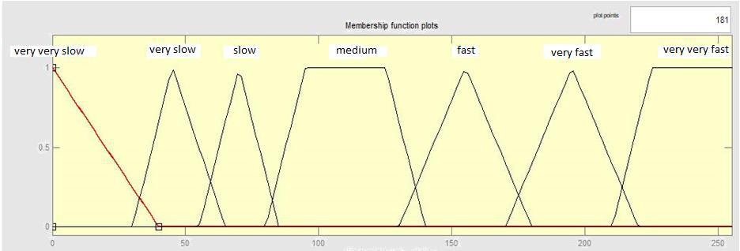

**Figure 2**. Membership Function Speed

Variable distance consists of 4 membership functions are very close, close, medium, and far.

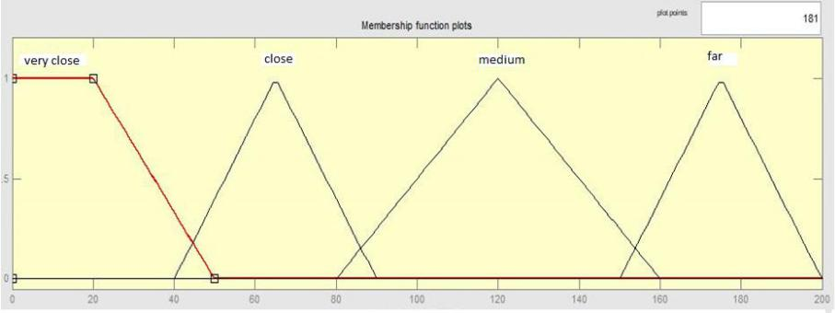

**Figure 3.** Membership Function Distance

Braking variable consists of 5 membership functions are very small, small, medium, full, and very full.

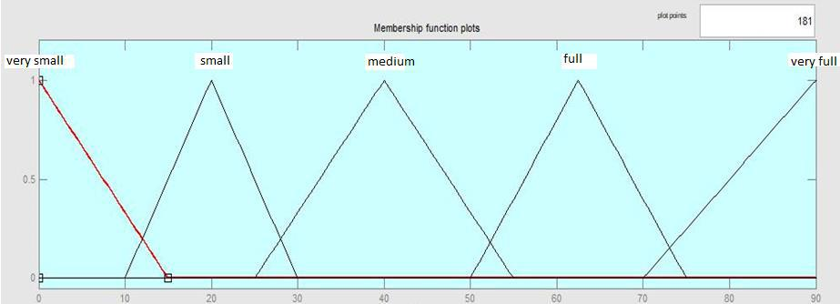

**Figure 4.** Membership Function Braking

Arduino mega 2560 system is a circuit devoted to operate IC (Integrated Circuit) microcontroller. This microcontroller is used as a central control system on automatic braking. The Arduino mega 2560 has a Port I/O functioned to receive input from ultrasonic sensors and PWM values and outputs to motor driver, servo motors, LCD, and buzzer. The embedded fuzzy logic system to arduino mega 2560 is to implement input, process and output by incorporating fuzzy logic program into arduino mega 2560 microcontroller. Fuzzy logic program is created using software by determining input and output as needed. After that create a fuzzy rule to process the input so that it gets output on fuzzy logic system. After fuzzy logic programming is done, the next step is to insert fuzzy logic program into arduino mega 2560 microcontroller, so that automatic braking system can run. Fuzzy logic rules are used to process input and functions membership in order to obtain output as decision making [10]. This system uses 2 input variables and 28 rule bases are shown at Table 1.

**Table 1.** Rule Base

|  |  |  |  |  |  |  |  |  |
| --- | --- | --- | --- | --- | --- | --- | --- | --- |
|  |  |  |  |  |  |  |  |  |

|  |  |  |  |  |  |  |  |  |  |  |  |
| --- | --- | --- | --- | --- | --- | --- | --- | --- | --- | --- | --- |
|  |  |  |  |  |  | Speed |  |  |  |  |  |
| Distance |  | Very very | Very | Slow |  | Medium | Fast |  | Very | Very Very |  |
|  |  |  |  | Fast | Fast |  |
|  |  |  |  |  |  |  |
|  |  |  |  |  |  |  |  |  |  |  |  |
| Very |  | Small | Small | Medium |  | Full | Very |  | Very | Very Full |  |
| close |  | Full |  | Full |  |
|  |  |  |  |  |  |  |  |  |  |  |  |
| Close |  | Very Small | Small | Small |  | Medium | Medium |  | Full | Very Full |  |
| Medium |  | Very Small | Very | Small |  | Small | Small |  | Small | Small |  |
| Small |  |
|  |  |  |  |  |  |  |  |  |  |  |  |
| Far |  | Very Small | Very | Very |  | Very | Small |  | Small | Small |  |
| Small | Small |  | Small |  |
|  |  |  |  |  |  |  |  |

**4. Result**

Prior to retrieval of data from prototype cars that have been designed, tested the proximity sensor and speed as input on the automatic braking system. Speed testing is done by measuring the Pulse Width Modulation (PWM) value as the speed input on the automatic braking system. The PWM value will be converted to cm/s by the IR sensor. So get the value of each tire speed on the prototype car. The IR sensor measurements are shown in Table 2.

**Table 2.** IR Sensor Measurement

|  |  |  |
| --- | --- | --- |
|  | PWM Value | IR Sensor Measurement |
|  | 200 | 67 cm/s |
|  | 255 | 72 cm/s |

Distance testing is done by using ultrasonic sensor HC SR-04 as the distance detector between prototypes of car with obstacle. The results of distance measurements using ultrasonic sensors are shown in Table 3.

**Table 3.** Ultrasonic Sensor Distance Measurement

|  |  |  |
| --- | --- | --- |
|  | Ultrasonic Sensor Measurement | Manual |
|  |  |  |
|  | 10 cm | 10 cm |
|  | 25.05 cm | 25 cm |
|  | 50.03 cm | 50 cm |
|  | 75 cm | 75 cm |
|  | 100.01 cm | 100 cm |
|  | 125 cm | 125 cm |
|  | 150 cm | 150 cm |
|  | 175.4 cm | 175 cm |
|  | 200 cm | 200 cm |

Figure 5 is a graph of the relationship between the average stopping distance of the prototype car against the variation of distance and speed.

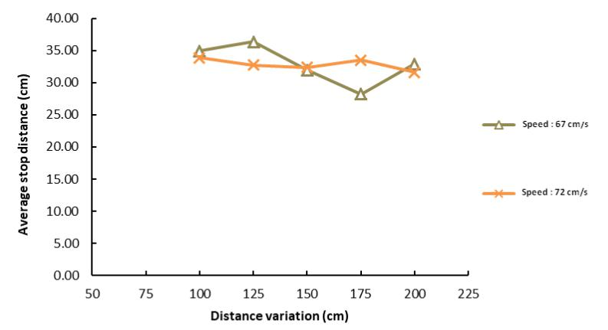

**Figure 5.** Average Stop Distance

Figure 5 shows that the stop distance at each test fluctuates, with a range of between 28 cm-36 cm. The difference in stopping distance across all tests is not due to the variation in distance and speed but on the performance of the components of the prototype of the car that responds to the servo motor response to any change in the output value of the fuzzy logic and the readings of the distance value by the ultrasonic sensor. Servo motors as actuators of automated braking systems have a vital role in determining the success of automobile prototype testing, to improve the response of servo motors to check the battery supply voltage to the servo motor periodically. The standard voltage of the servo motor is 6.4 volts.

The test results show prototype car can stop with distance more than 15 cm to obstacle, so testing of car prototype in this research have success rate equal to 100%. Figure 6 is a graph of deceleration of prototype car testing results against variations in distance and speed.

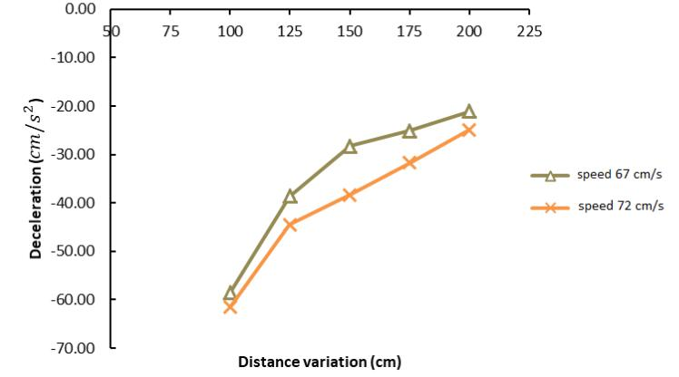

**Figure 6.** Deceleration of Prototype Car

Figure 6 there is a tendency that the higher the speed of the prototype of the car, the greater the resulting slowdown. At a speed of 72 cm/s the resulting slowdown of any distance variation is greater than the other velocity values with the same distance variation. Theoretically the value of deceleration is influenced by 2 variables, the first is the time it takes the prototype of the car from running to stop and the second is the initial speed of the prototype car. The longer it takes to stop the speed of the prototype of the car, the smaller the retarding value. The value of the prototype deceleration of the car is related to the fuzzy logic system that is designed as the input value processor and produces the output of a braking angle. The greater the angle of braking results fuzzy logic output, then the value of prototype deceleration of the car the greater. The deceleration results in all tests that have been performed show that the fuzzy system is designed to run well, so the value of the prototype deceleration of the car is directly proportional to the output of processed fuzzy logic in the form of braking angle. Figure 7 is a graph of braking accuracy of test results and software calculations.

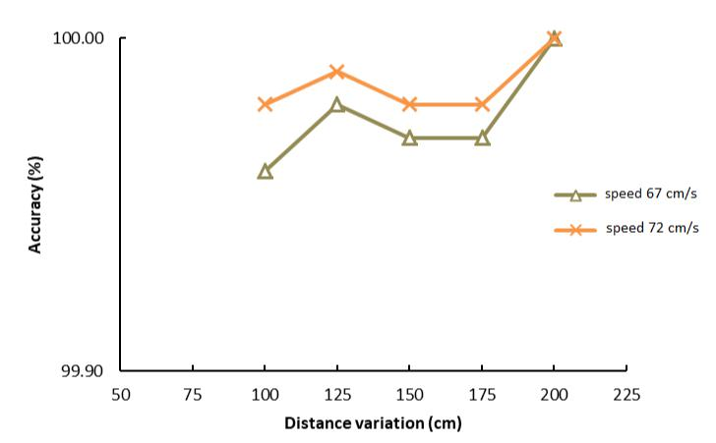

**Figure 7.** Braking Accuracy

Figure 7 shows the accuracy of braking at all variations of speed and distance between 99.96% - 100%. Maximum percentage of braking error of 0.22% at speed of 67 cm/s and the initial distance of 100 cm. The occurrence of braking error on this system is due to the reading of distance value as fuzzy logic input on prototype of car is decimal number two behind coma, whereas at software calculation distance value is decimal number one behind coma so brake angle output value slightly different. In the software calculation if the decimal value of two behind the comma is entered, software will automatically do the rounding to a decimal number one behind the comma. The automated braking system using the fuzzy logic method in this study runs well so that it has an accuracy value close to 100% in all tests. Compare with previous study that discuss about antilock brake system, the fuzzy logic have error and error rate as input variables and percentage of braking as a output variable. The simulation of automatic braking system controller based on fuzzy logic,whether brake time or brake distance are all achieve a great control effect, guarantee the steady of braking, the fitness of brake efficiency, and the requirements of national safety specifications for vehicles operating on roads. When the brake time within 0.5 second, slip rate increase rapidly, vehicle speed decrease quickly as time goes on, while the slip rate is up to about 20%, slip rate change constantly and vehicle speed keep on decreasing as the increase of brake time

**5. CONCLUSION:**

In conclusion, the fuzzy logic project has explored the application of fuzzy sets and fuzzy logic in solving complex problems. By utilizing fuzzy membership functions, fuzzy rules, and defuzzification methods, we have successfully modeled and analyzed systems, making informed decisions based on uncertain or imprecise data.

Throughout the project, we delved into the principles of fuzzy logic and its practical implementation. We designed fuzzy sets and membership functions to represent linguistic variables and their degrees of membership, capturing ambiguity and vagueness in real-world systems.

By defining fuzzy rules and constructing rule-based systems, we emulated human-like reasoning and leveraged expert knowledge. Fuzzy inference allowed us to process inputs and derive appropriate outputs, considering multiple rules and membership functions.

Additionally, we explored defuzzification methods to convert fuzzy outputs into crisp values for practical implementation. Techniques such as Center of Gravity, Bisection, and Mean of Maxima enabled us to obtain crisp results applicable in real-world systems.

In summary, the project highlighted the effectiveness and versatility of fuzzy logic in addressing real-world problems. By incorporating fuzzy sets, fuzzy rules, and defuzzification methods, we developed intelligent systems capable of handling imprecise information and providing valuable insights. This contributes to the field of fuzzy logic and paves the way for future applications in various domains where traditional logic and mathematical models may be limited.

**FUTURE SCOPES:**

Determining the future scope of a project, especially one related to the automatic braking system using fuzzy logic, depends on various factors, including the specific findings and advancements made in the research. However, here are some general directions in which the future scope of such a project could evolve:

Integration with Advanced Driver Assistance Systems (ADAS):

The future scope may involve integrating the fuzzy logic-based ABS with other advanced safety systems, forming a comprehensive Advanced Driver Assistance System. This could include features such as collision avoidance, adaptive cruise control, and lane-keeping assistance.

Machine Learning Integration:

Further advancements could involve incorporating machine learning techniques to enhance the adaptive capabilities of the braking system. Machine learning algorithms could continuously learn from real-world driving data, improving the system's response to a wide range of scenarios.

Connected Vehicle Technologies:

Integration with connected vehicle technologies is another potential avenue. Communication between vehicles (V2V) and between vehicles and infrastructure (V2I) could enhance the effectiveness of the ABS by providing additional information about road conditions and potential hazards.

Cybersecurity Considerations:

As vehicles become more connected and autonomous, there's an increasing need to address cybersecurity concerns. The future scope might include research on securing the fuzzy logic-based ABS against cyber threats to ensure the safety and integrity of the braking system.

Autonomous Vehicle Applications:

With the growing interest in autonomous vehicles, the future scope could extend to adapting the fuzzy logic-based ABS for use in autonomous driving scenarios. This involves developing braking systems that work seamlessly with the decision-making processes of autonomous vehicles.

Energy Efficiency and Sustainability:

Future research may focus on optimizing the fuzzy logic-based ABS for energy efficiency, contributing to overall vehicle sustainability. This could involve developing braking strategies that minimize energy consumption while maintaining safety standards.

Global Standardization and Regulation:

If the research proves successful, there may be a future scope in contributing to the development of global standards and regulations for fuzzy logic-based braking systems. This could involve collaboration with regulatory bodies and industry stakeholders to ensure the widespread adoption of advanced braking technologies.

Human-Machine Interaction (HMI):

Considering the increasing role of human-machine interaction in modern vehicles, the future scope may include research on user interfaces and feedback mechanisms to ensure that drivers understand and trust the actions of the fuzzy logic-based ABS.

It's essential for the researchers and stakeholders to monitor developments in automotive technology, safety standards, and regulatory requirements to align the project's future scope with emerging trends and needs in the automotive industry.

# References

[1] F. Diederichs, T. Schuttke, and D. Spath, “Driver Intention Algorithm for Pedestrian Protection and Automated Emergency Braking Systems,” in IEEE Conference on Intelligent Transportation Systems,Proceedings, ITSC, Oct. 2015, vol. 2015-October,pp. 1049–1054. doi: 10.1109/ITSC.2015.174

[2]A. Schneider, M. Lienkamp, R. Markus, and L. T. Munich Germany Franz, “Method to estimate the field effectiveness of an automatic braking system in combination with an adaptive restraint system in frontal crashes Optimizing the Charging Station Placement under Consideration of the UserCharging Behavio View project Predictive Fleet 5 Operations for On-Demand Mobility ServicesView project Method to estimate the field effectiveness of an automatic braking system in combination with an adaptive restraint system in frontal crashes,” 2011. [Online]. Available: https://www.researchgate.net/publication/281271790

[3] . Kobiela and A. Engeln, "Autonomous emergency braking studies on driver behaviour", ATZworldwide, vol. 112, no. 10, pp. 4-8, 2010. Available: 10.1007/bf03225144

[4] M. A. Abu, Z. Kornain, M. H. Rosli, and I. M. Iqbal, “Automated Car Braking System using Labview,” in ISIEA 2010 - 2010 IEEE Symposium on Industrial Electronics and Applications, 2012, pp. 246–250. doi:10.1109/ISIEA.2012.6496638

[5] V. Handi, S. Jeyanthi and A. Giridharan,"Development of Automated Braking System for Collision Avoidance of Vehicles", International Journal of Vehicle Structures and Systems, vol. 10, no. 2, 2018. Available: 10.4273/ijvss.10.2.04

[6] K. v Gawande, M. A. Shende, V. B. Meshram, and A. Professor, “AUTOMATIC PNEUMATIC BRAKING SYSTEM,” 2017. [Online]. Available: [www.jetir.org](http://www.jetir.org)

[7] C. Huang, P. Hang, J. Wu, A. T. Nguyen, and C. Lv, “Reference-Free Human-Automation Shared Control for Obstacle Avoidance of Automated Vehicles,” in IEEE Transactions on Systems, Man, and Cybernetics: Systems, Oct. 2020, vol. 2020- October, pp. 4398–4403. doi: 10.1109/SMC42975.2020.9283287

[8] Michael Negnevitsky, Artificial Intelligence, Second Edition, 2005, Pearson Education Ltd. 2002

[9] A. Kalhari, N. Wickramarathna, L. Yapa, D. Nandasena and L. Kalansooriya, "Development of Automated Aquatic Taxi for Sri Lanka using Kansei Engineering Concept", Ir.kdu.ac.lk, 2021. [Online]. Available: http://ir.kdu.ac.lk/handle/345/2985. [Accessed: 01- Nov- 2021]. View publication stats

[10] U.S. Department of Transportation,” Traffic Safety Facts 2009,” DOT-HS-811-392

[11] I. Fletcher, B. J. B. Arden, and C. S. Cox, “Automatic Braking System Control,” in IEEE International Symposium on Intelligent Control - Proceedings, 2003, pp. 411–414. doi: 10.1109/isic.2003.1254670

[12] T. Toroyan, "Global status report on road safety", Injury Prevention, vol. 15, no. 4, pp. 286- 286, 2009. Available: 10.1136/ip.2009.023697.